**Dress Code Policy**

Wearing of the Munno Para Primary School uniform is compulsory for all students in Reception through to Year 6. School uniform is important because:

* it supports student safety through ease of identification
* it creates a sense of identity among students and the community
* it promotes a positive image of the school
* it ensures students are dressed appropriately for all school activities.

**Clothing**

The following items are considered part of our school uniform:

* green and yellow collared shirts with the Munno Para Primary School logo or plain bottle green collared shirts
* plain black shorts, skirts, skorts or shorts (mid-length or longer) or plain long black pants (no stripes or patterns)
* green and white gingham summer dress, mid-length or longer
* plain bottle green or black long-sleeved top to be worn under school t-shirt
* green and yellow Munno Para School jacket or plain bottle green jacket/jumper
* no denim is to be worn
* Year 6 students may purchase commemorative shirts and jumpers and wear these in place of the green and yellow t-shirts and jackets.

Examples:

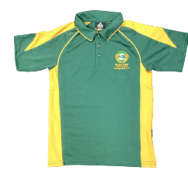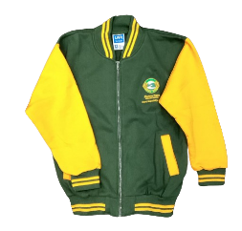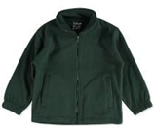

**School shoes**

For health and safety reasons students are required to wear sneakers, sport shoes or closed in shoes at all times.

**Hats**

At Munno Para Primary School we value sun safe practices. A ‘No hat no play’ policy is enforced year-round. Students are required to wear a hat when:

* A green hat on a white background

  Description automatically generatedthey are playing outside
* they participate in any outside lessons
* they are on excursions which are held outdoors
* hats must be a plain green wide brimmed hat or bucket hat- no caps or logos
* students without a hat or who choose not to wear a hat will be directed by our staff to move into a shaded area. Hats are not to be worn inside school buildings.

**Jewellery**

Jewellery that is permitted include:

* small sleeper or stud earrings
* a watch

Students wearing jewellery that is deemed as a safety risk may be asked to remove it and put into their school bags. Some students may have religious, cultural or medical requirements where it is important to wear certain items. If this applies to you please arrange a time to discuss this with one of the leadership team members.

**Hair**

Hair that is below the collar is encouraged to be tied back. This can assist in the prevention of and transmission of head lice.

**Make-up**

Make-up is not permitted, students wearing make-up will be asked to remove it.

**Process for students not wearing school uniform**

* reminder (in class)
* class communication and dress code policy sent home (in class)
* if ongoing, teacher will communicate with family about expectations around dress code policy.

It is an expectation that students wear school uniform when attending off-site excursions.

Endorsed by Governing Council Date: Sept 2024

Review date: Dec 2025